**PIZZA SALES (YT TUTORIAL POWER BI & SQL)**

**KPI**

1. **Total Revenue**

SELECT SUM(total_price) AS Total_Revenue from pizza_sales

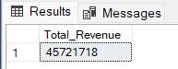

1. **Average Order Value**

SELECT SUM(total_price) / COUNT (DISTINCT order_id) AS Average_Order_Value FROM pizza_sales

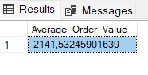

1. **Total Pizza Sold**

select sum(quantity) as Total_Pizza_Sold from pizza_sales

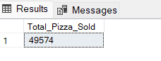

1. **Total Orders**

select count (distinct order_id) as Total_Orders from pizza_sales

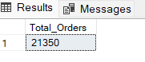

1. **Average pizza**

select cast(cast(sum(quantity) as decimal (10,2)) /

cast(count(distinct order_id) as decimal (10,2)) as decimal (10,2)) as Avg_Pizzas_per_Order from pizza_sales

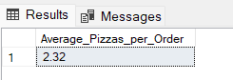

**Charts**

1. **Daily trend for total orders**

SELECT DATENAME(DW, order_date) AS order_day , COUNT(DISTINCT order_id) AS Total_orders FROM pizza_sales

GROUP BY DATENAME(DW, order_date)

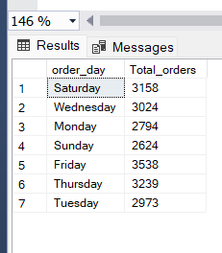

1. **Hourly trend for total orders**

SELECT DATENAME(MONTH, order_date) AS order_day , COUNT(DISTINCT order_id) AS Total_orders_Month FROM pizza_sales

GROUP BY DATENAME(MONTH, order_date)

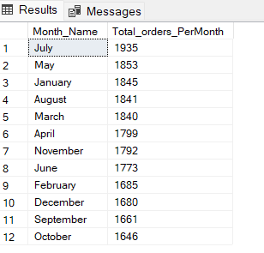

1. **Percentage of sales by pizza category**

SELECT pizza_category, SUM(total_price) * 100 / (SELECT SUM(total_price) FROM pizza_sales) AS Total_Sales_percentage

FROM pizza_sales

GROUP BY pizza_category

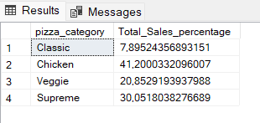

1. **Percentage of sales by pizza size**

SELECT pizza_size, CAST(SUM(total_price) AS DECIMAL (10,2)) as Total_Sales, CAST(SUM(total_price) * 100 /

(SELECT SUM(total_price) FROM pizza_sales WHERE DATEPART(QUARTER, order_date)=1) AS DECIMAL(10,2))

AS Total_Sales_percentage FROM pizza_sales

WHERE DATEPART(QUARTER, order_date)=1

GROUP BY pizza_size

ORDER BY Total_Sales_percentage DESC

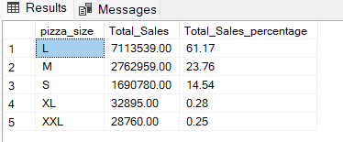

1. **Total pizza sold by pizza category**

SELECT pizza_category, CAST(SUM(total_price) AS DECIMAL(10,2)) as total_revenue,

CAST(SUM(total_price) * 100 / (SELECT SUM(total_price) from pizza_sales) AS DECIMAL(10,2)) AS Total_sales_Percentage

FROM pizza_sales

GROUP BY pizza_category

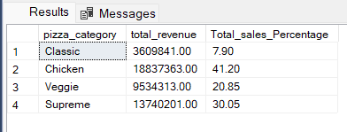

1. **Top 5 best sellers by revenue, total quantity and total orders**

select top 5 pizza_name, SUM (total_price) as Total_Revenue FROM pizza_sales

GROUP BY pizza_name

ORDER BY Total_Revenue desc

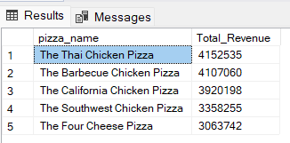

1. **Bottom 5 best sellers by revenue, total quantity and total orders**

SELECT Top 5 pizza_name, SUM(total_price) AS Total_Revenue

FROM pizza_sales

GROUP BY pizza_name

ORDER BY Total_Revenue ASC

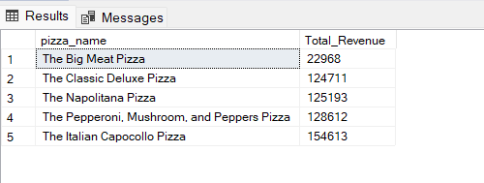

1. **Top 5 pizza by quantity**

select top 5 pizza_name, sum(quantity) as Total_Pizza_Sold

from pizza_sales

group by pizza_name

order by Total_Pizza_Sold DESC

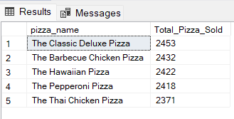

1. **Bottom 5 pizza by quantity**

select top 5 pizza_name, sum(quantity) as Total_pizza_sold

from pizza_sales

group by pizza_name

order by Total_pizza_sold asc

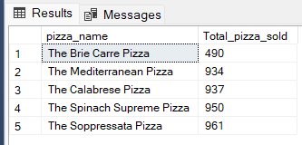

1. **Top 5 pizza by total orders**

select top 5 pizza_name, count(distinct(order_id)) as total_order

from pizza_sales

group by pizza_name

order by total_order desc

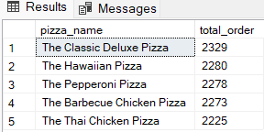

1. **Bottom 5 pizza by total orders**

select top 5 pizza_name, count(distinct(order_id)) as total_order

from pizza_sales

group by pizza_name

order by total_order asc

